**HALF ADDER**

**EXP NO.1:**

AIM: To show the working of half adder using logisim.

Truth table:

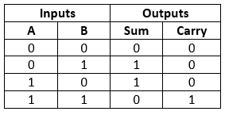

OUTPUT:

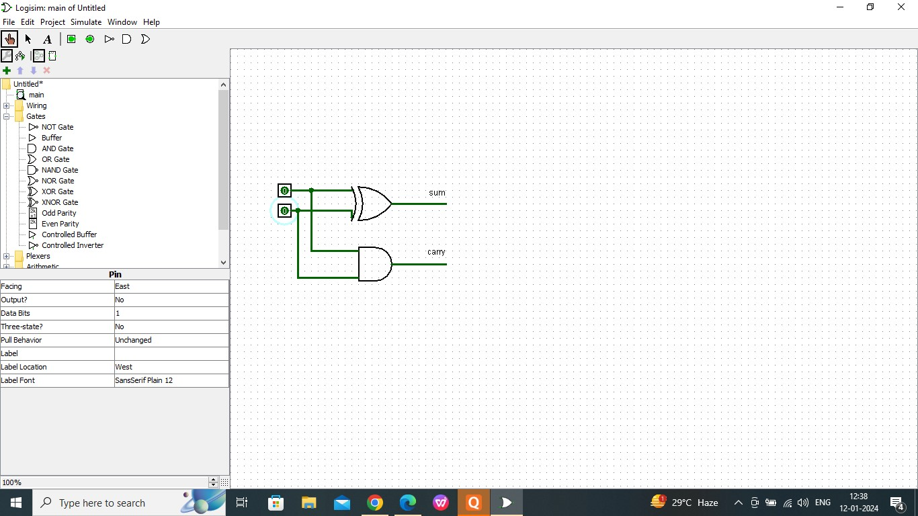

RESULT:

Thus the working of half adder has been observed successfully using logisim.